M. MEHDI AFSAR, TRAFFORD CRUMP, and BEHROUZ FAR, (2022Reinforcement Learning based Recommender Systems:A Survey. ACM Comput. Surv. 55, 7, Article 145 (December 2022), 38 pages.
Main research question:
a survey on reinforcement learning based recommender systems (RLRSs) is presented. Our aim is to present an outlook on the field and to provide the reader with a fairly complete knowledge of key concepts of the field. We first recognize and illustrate that RLRSs can be generally classified into RL- and DRL-based methods. Then, we propose an RLRS framework with four components, i.e., state representation, policy optimization, reward formulation, and environment building, and survey RLRS algorithms accordingly. We highlight emerging topics and depict important trends using various graphs and tables. Finally, we discuss important aspects and challenges that can be addressed in the future.
The main elements of an RL system are:
• Policy: policy is usually indicated by π and gives the probability of taking action a when the agent is in state s. Regarding the policy, RL algorithms can be generally divided into on-policy and off-policy methods. In the former, RL methods aim at evaluating or improving the policy they are using to make decisions. In the latter, they improve or evaluate a policy that is different from the one used to generate the data.
• Reward signal: upon selecting actions, the environment provides a numerical reward to inform the agent how good or bad are the actions selected.
• Value function: the reward signal is merely able to tell what is good immediately, but the value function defines what is good in the long run.
• Model: model provides the opportunity to make inferences about the behavior of the environment. For instance, the model can predict next state and next reward in a given state and action.
Problem formulation in recommender systems
• State S: a state st ∈ S is defined as the user preferences and their past history with the system.
• Action A: an action at ∈ A is to recommend an item to the user at time step t .
• Reward R: the RL agent receives reward r (st , at ) ∈ R based on the user feedback on the recommendation provided.
• Transition probability P: transition probability p(s _ |s, a) ∈ P is the probability of transition from s = st to s _= st+1 if action a is taken by the agent.
• Discount factor γ : discount factor γ ∈ [0, 1] is the discount factor for future rewards.With γ = 0, the agent becomes myopic, i.e., it only focuses on immediate reward. On the contrary, if γ = 1, the agent becomes farsighted and focuses more on future rewards [27].
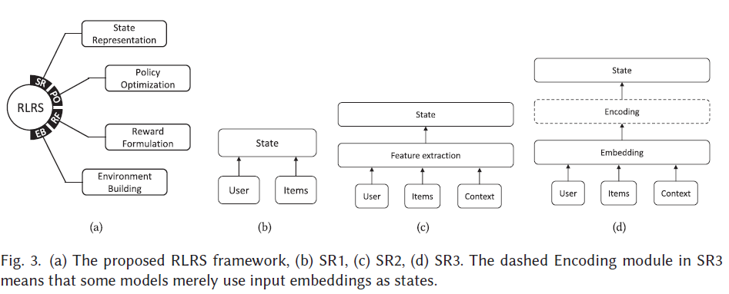
- RL-based Algorithms. RL algorithms could be divided into tabular and approximatemethods. Popular tabular methods include dynamic programming(policy iteration and value iteration), Monte Carlo, and temporal difference（Q-learning and Sarsa）.

This paper demonstrates the concept of reinforcement learning and how to map the concept to the recommender systems environment, but it didn’t apply in a real case.

